Adult Protective Service (APS)
Area 10

Contact: Wendy Scott, APS Director
Location:120 West 7th Street, Suite 210
Bloomington IN 47404 (Map)
Phone:812-349-2665
Fax:812-349-2798
Hours:8:00 am - 4:00 pm
Monday - Friday
Closed all Federal Holidays
E-mail: APS10@co.monroe.in.us
Serving: Monroe, Morgan and Owen Counties

Adult Protective Services Hotline: 1-800-992-6978
If the endangered adult is in immediate danger, dial 9-1-1 or call the police immediately!

The Monroe County Prosecutor’s Office runs the Adult Protective Services (APS) program for Area 10 covering Monroe, Owen, and Morgan Counties. Adult Protective Services investigates reports of endangered adults and may take legal action to protect elderly and disabled victims. Investigators may also use medical and psychiatric resources in the community as necessary to protect the health and safety of endangered adults. These resources include Area 10 Agency on Aging, hospitals, mental health centers, residential placement facilities, agencies serving individuals with developmental disabilities, and other social service agencies.
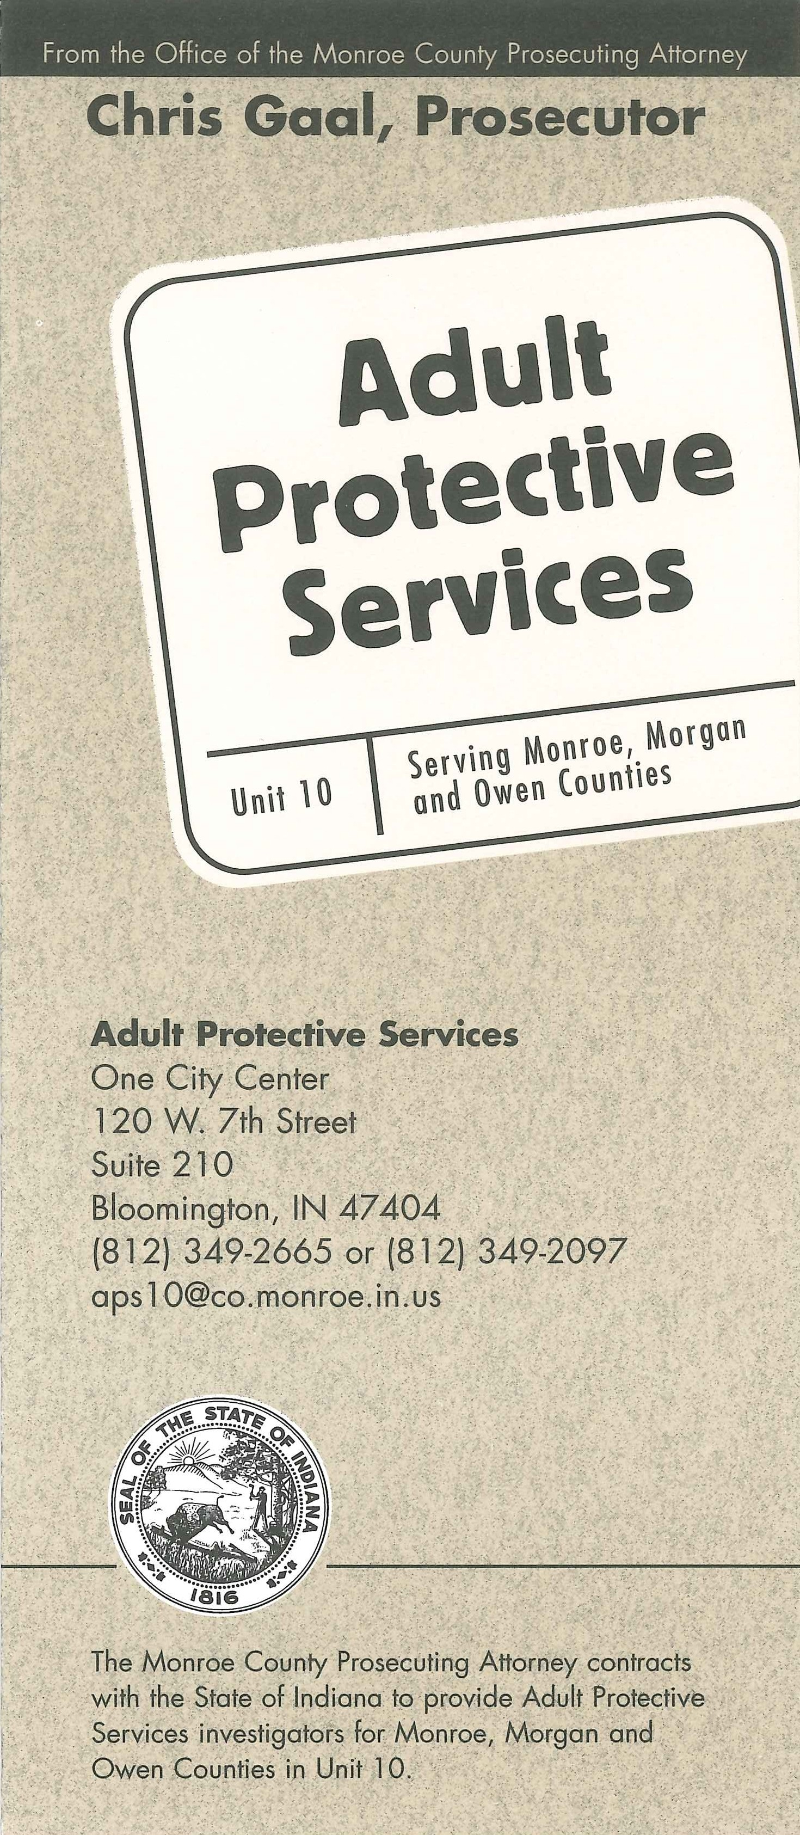
Click here to view the Adult Protective Services brochure for Area 10.

WHAT IS AN ENDANGERED ADULT?
- An endangered adult is someone 18 years or older who:
- Due to mental illness, mental retardation, dementia, habitual drunkenness, excessive use of drugs, or other physical or mental incapacity, is incapable of managing his or her property, or providing or directing the provision of self-care
AND
- is harmed or threatened with harm as a result of
Neglect
Battery or
Exploitation of personal services or property.

- Common causes of mental incapacity.
  - Dementia
  - Alzheimer’s
  - mental illness
  - mental retardation
  - habitual drunkenness
  - excessive use of drugs
- Common causes of physical incapacity.
  - Illness causing prolonged weakness
  - Accidents which could result in spinal injury, amputation, acquired brain injury affecting motor skills and limb control.

TYPES OF ABUSE:

- Physical abuse includes slapping, hitting, bruising, beating or any other intentional act that causes someone physical pain, injury or suffering. Physical abuse also includes excessive forms of restraint used to confine someone against their will (i.e., tying, chaining or locking someone in a room).

- Emotional abuse is threatening, intimidating or humiliating an individual and causing them emotional pain, distress or anguish. Emotional abuse can be verbal or non-verbal; it includes insults, yelling and threats of harm or isolation.

- Sexual abuse is any sexual activity to which the older or dependent adult does not consent or is incapable of consenting. Non-consensual sexual activity includes everything from exhibitionism to sexual intercourse.

- Financial or material exploitation is when someone misuses, mishandles or exploits the elderly or dependent adult's property, possessions or financial assets. This includes using those assets without the individual's consent or manipulating the older or dependent adult for the financial benefit or material gain of another.

- Neglect takes place when, intentionally or unintentionally, a caregiver fails to support the physical, emotional and social needs of the elder or dependent adult. Neglect can include denying food or medication, health services or contact with friends and family. Neglect is the most common form of elder mistreatment in domestic settings.

- Isolation means any of the following:
  - Acts intentionally committed for the purpose of preventing, or that serve to prevent, an elder or dependent adult from receiving his or her mail or telephone calls.
  - Telling a caller or prospective visitor that an elder or dependent adult is not present, or does not wish to talk with the caller, or does not wish to meet with the visitor where the statement is false, is contrary to the express wishes of the elder or the dependent adult, whether he or she is competent or not, and is made for the purpose of preventing the elder or dependent adult from having contact with family, friends, or concerned persons.

• False imprisonment – The detention of a person without his or her consent and without lawful authority.
- Physical restraint of an elder or dependent adult, for the purpose of preventing the elder or dependent from meeting with visitors may constitute false imprisonment.

- Abandonment occurs when a caregiver deserts an elderly or dependent person.

- Self-neglect requires intervention when elderly or dependent adults fail to meet their own physical, psychological or social needs or they threaten their health or safety in any way. Often times, physical or mental illness, isolation or substance abuse prevent elderly or dependent adults from being able to take care of their own basic needs.

SIGNS OF TROUBLE:

The following items are possible warning signs that abuse might be occurring to an endangered adult. If you observe some or all of these occurring with an endangered adult you know, contact Adult Protective Services.

- Injury that is inconsistent with the explanation for its cause

- The endangered adult has recently become confused or disoriented

- The caregiver shows anger, indifference, or aggressive behavior toward the person

- Personal belongings, papers, or credit cards are missing

- Hesitation from the elder to talk openly

- The caregiver has a history of substance abuse, mental illness, criminal behavior or family violence

- Lack of necessities such as food, water, utilities, medications and medical care

- Another person's name added to the client's bank account or important documents, or frequent checks made out to CASH

COMMON REPORTERS:

An individual who believes or has reason to believe that someone is an endangered adult and is the victim of abuse, neglect or exploitation is required by law to make a report to law enforcement, Adult Protective Services, or through the APS Hotline 1-800-992-6978.
Although everyone is required to report, some people who work closely with the elderly more commonly report suspected abuse.
Examples of people who commonly report:
  - Family Members
  - Care Custodians
  - Health Practitioners
  - County Welfare Departments
  - Employees of Law Enforcement Agencies
  - Employees of Fire Departments
  - Employees of humane societies and animal control agencies
  - Employees of environmental health and building code enforcement
  - Clergy members
  - Any other protective, public, sectarian, mental health, private assistance, or advocacy agency, or person providing health services or social services to elders or dependent adults
  - Any person who has assumed full or intermittent responsibility for care or custody of an elder or dependent adult.

- Every APS case starts with the initial abuse report. In order for the APS program to respond, a report must be filed with the local APS Unit (http://www.in.gov/fssa/files/APS_Unit_Map.pdf) or through the APS Hotline 1-800-992-6978 .

:
FREQUENTLY ASKED QUESTIONS

Make An Online Report

Crimes Against the Elderly

Monroe County Pharmaceutical Safe Disposal Program

RESOURCES LINK

