MEDIA RELEASE
January 27, 2014

Contact:
Chris Gaal, Monroe County Prosecuting Attorney
cgaal@co.monroe.in.us
(812) 349-2670

Cyrilla Helm, Foundation for Monroe County Community Schools
mhelm@mccsc.edu
(812) 330-7700

“CHILDREN & TECHNOLOGY: A PARENT’S GUIDE”
VIDEO AND PANEL DISCUSSION

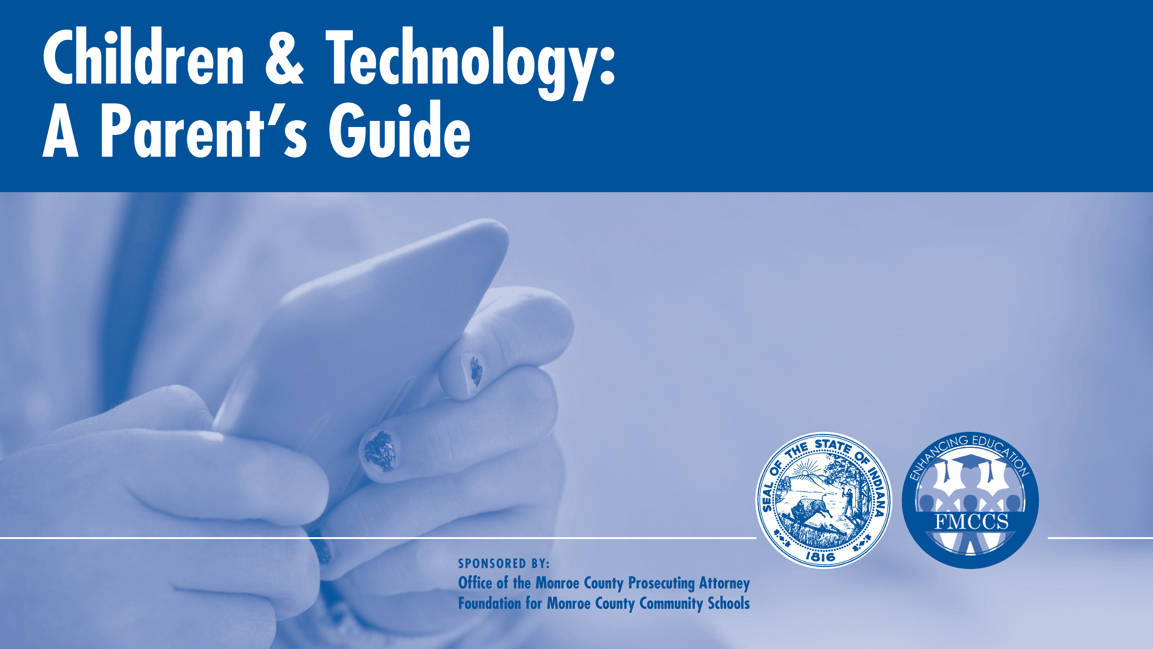

Click Here to watch the video.

When do you give your child a smart phone with internet access and a camera? When can they set up a Facebook account? Can they post pictures online? Should you set rules on texting? These questions didn’t occur to parents a generation ago. But they are just a few of the many technology questions being faced by parents today.

Today’s kids are surrounded by technology, both during school and after. It is important for kids to learn how to responsibly use the many tools available on computers and smart devices. But unsupervised access to technology can also create risks for children. Just like with television, there is content online that may not be appropriate for children.

Schools have rules for the acceptable use of technology by students. But it is also important for parents to think about how to exercise online supervision in order to preserve privacy and avoid problems such as sexting and cyber-bullying.

Help is on the way. The Monroe County Prosecutor’s Office and the Foundation for Monroe County Community Schools have teamed up to offer suggestions to assist parents in developing their own rules for safely monitoring and setting limits on the use of technology by children. Tips are summarized in a video and fact sheet that will be distributed for free online, and will also be the topic of discussion at a “Community Chat” public forum sponsored by the Foundation at the Jackson Creek Middle School Auditorium on Monday, February 3 from 6:30 to 8 pm. .

“Many of us who are parents today didn’t have social media, texting, and smart phones with cameras when we were kids,” says Monroe County Prosecutor Chris Gaal. “It can be hard for today’s parents to keep up with the fast pace of technological change. We hope this resource guide will help them create rules that reflect their own values as parents, and that can develop over time as their child grows older and matures.”

Topics include:

• Teaching Children About Technology
• Monitoring Your Child’s Computer Use
• Setting Limits on Technology
• Online Privacy
• Social Media
• Sexting
• Cyber-bullying
• Online Predators

According to MCCS Foundation Executive Director Cyrilla Helm, technology in the classroom is here to stay. “Computer literacy is part of basic literacy,” says Helm. “New teaching methods are incorporating web-based research, digital collaboration and digital story telling. Each student is now required to have an iPad and become proficient with basic computer applications.”

But students not only access the internet during school, but also after – and not only on computers, but also on smart devices and even gaming systems.

“It’s important to start a conversation with parents so that we can prevent some of the problems that can result from greater access to technology by children,” says Rebecca Rose, Director of Social Services for Monroe County Community School Corporation (MCCSC).

To coincide with the release of the video and start the discussion, the Foundation will sponsor a “Community Chat” featuring local experts to discuss many of the topics touched on in the video. The public forum will be on Monday, February 3 at Jackson Creek Middle School auditorium from 6:30 to 8 pm. Free childcare will be provided.

Panelists will include:

Chris Gaal, Monroe County Prosecuting Attorney
Jeff Henderson, Bloomington North High School, Principal
Christine McAfee, Monroe County Juvenile Probation
Emily Perry, Susie’s Place Child Advocacy Center
Rebecca Rose, Director of Social Services, MCCSC

The free You Tube video may be seen from the Prosecutor’s Office website at www.monroeprosecutor.us and from the Foundation website at www.mccsfoundation.org.

* * *

