MENTAL HEALTH REVIEW TEAM

REFERRAL FORM

Defendant’s name: Referrer’s name:

Date:

Defense attorney: Deputy Prosecutor:

Reasons for referral (specifics instances of conduct, please):

Does the defendant agree to have his/her case reviewed by the MHRT? _____Yes _____No
Is the defendant currently in treatment? _____Yes _____No
Has the defendant been in treatment in the last year? _____Yes _____No
Has the defendant signed a HIPPA waiver or release? _____Yes _____No
Is the defendant currently in custody? _____Yes _____No

Please list the defendant’s current treatment providers and all treatment providers seen in the past five years, along with approximate dates of treatment.

DEFENSE ATTORNEYS: If the defendant is not a client of Centerstone, or sees providers in addition to those at Centerstone, please provide all treatment records for the past year, along with a letter from the treatment provider indicating the following:
- diagnosis
- prognosis
- course of treatment, including medications
- history of compliance with treatment
- frequency of appointments
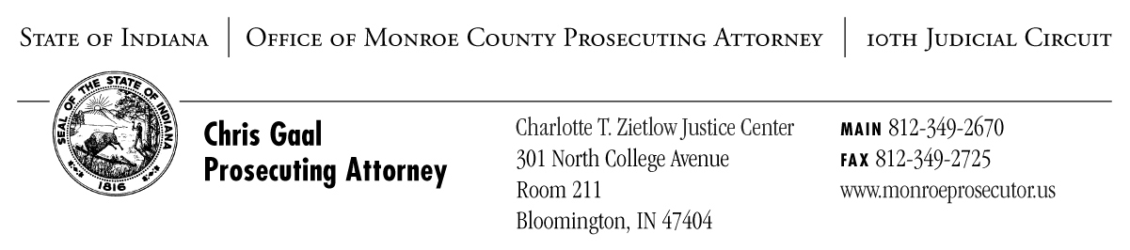
You will likely need your client to execute a medical release form to obtain the required records. Check with the provider as soon as possible. Requests for records should be done prior to the submission of this referral application to expedite the process. If you have any difficulty obtaining records contact Trish Bushey at the Prosecutor’s Office.

